**UI wire frame – Farm2Table**

1. **Home Page**

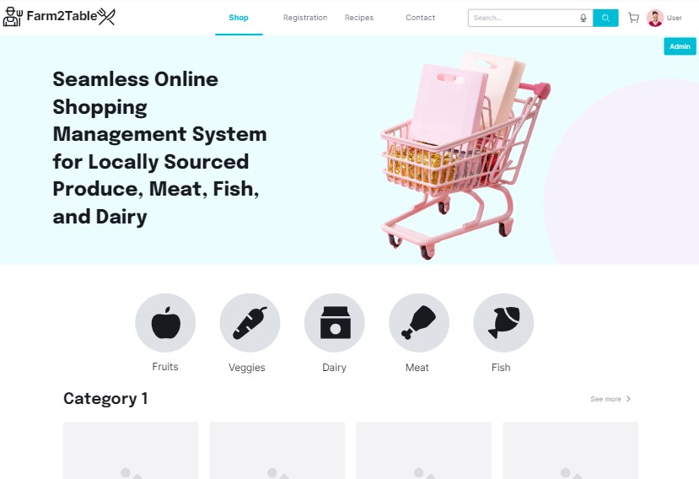

1. **Admin Login Page**

1. **Admin CRUD(View/Add/Delete/Update) Categories Page**

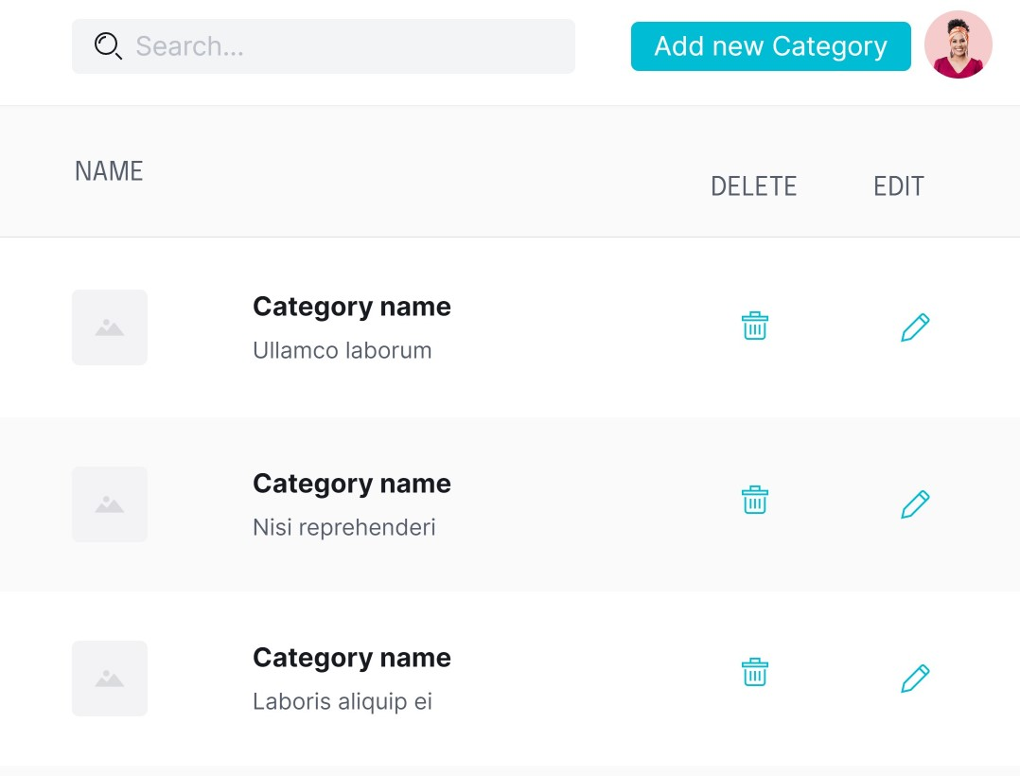

1. **Admin CRUD(View/Add/Delete/Update) Products Page**

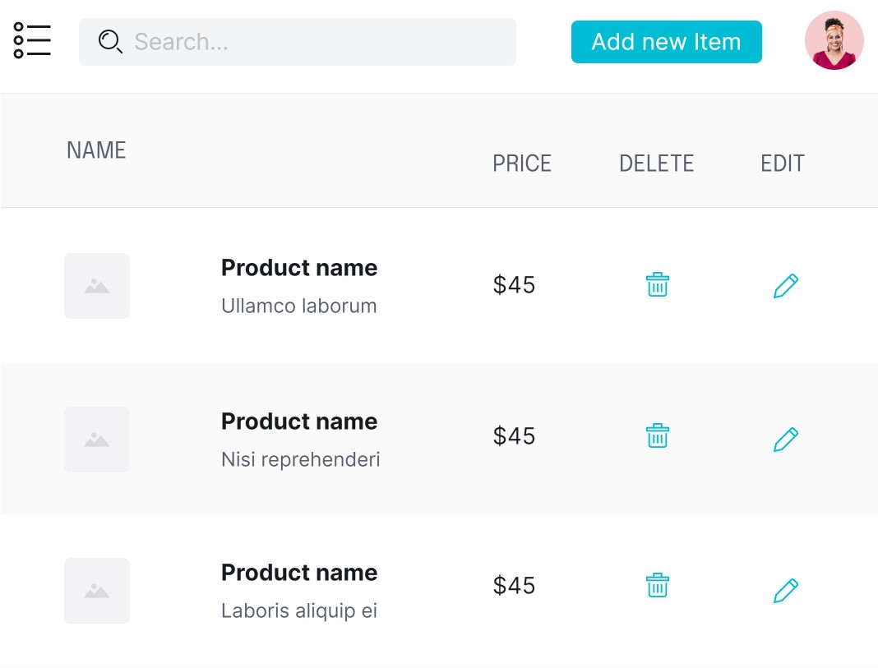

1. **User Sign In**

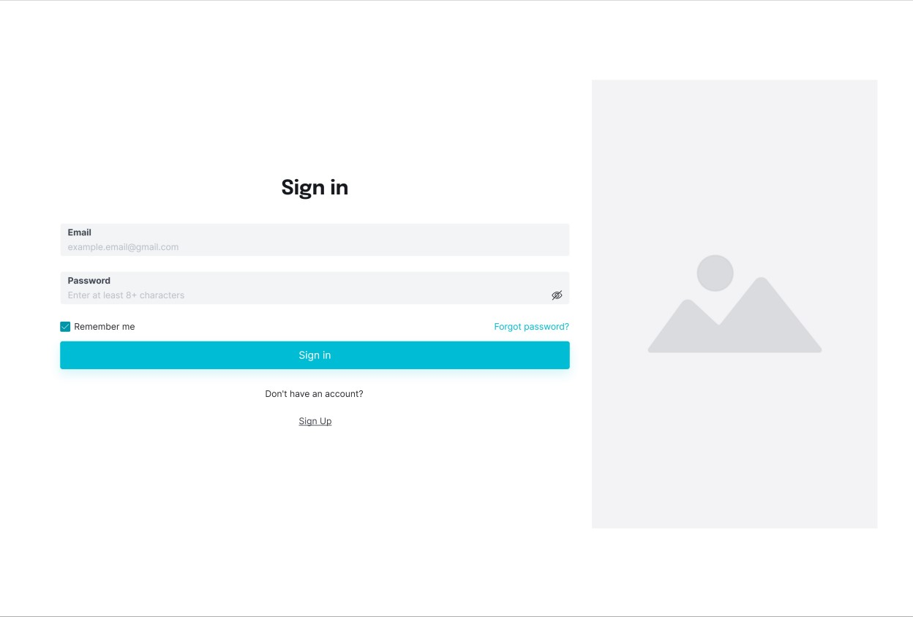

1. **User Registration**

1. **Product View**

1. **Cart**

1. **Rating**

